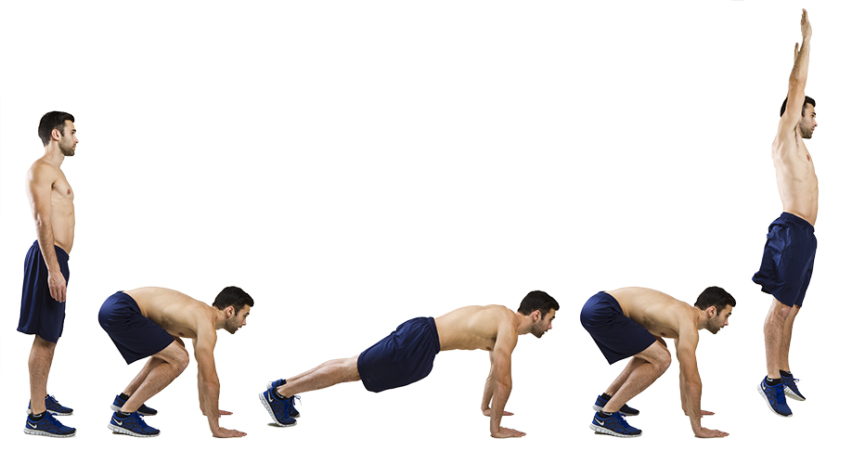
Burpee
The benefit: Burpees are a full body exercise but here are just a few of the muscles they work, deltoids, biceps, triceps, pectorals major, obliques, abdominals, quadriceps, gluteus maximus, hamstrings and gastrocnemius (calf) just to name a few.

How to do it: Stand with your feet hip width apart and your arms down by your side. Lower into a squat position with your hands flat on the floor in front of you. Kick your legs backwards into a press up position and lower your chest to the floor. Push your chest back up to the press up position thrust both feet forward so you are back in the squat position. Jump up and raise both hands over your head.

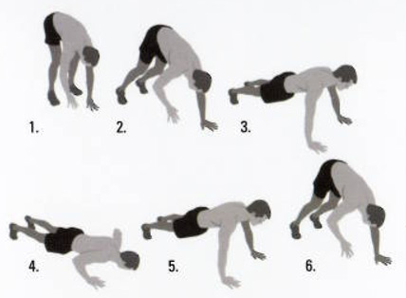
Inchworm
Benefits: The inchworm is a multi-joint, dynamic exercise that increases strength and muscular endurance throughout the entire body with an emphasis on the shoulders and core.

How to do it: Stand tall with your legs extended straight. Bend over from the hips and touch the floor with your palms flat on the floor. Keep your legs straight as you walk your hands as far forward as you can. Don’t let your hips sag. Take small steps and walk your feet to your hands. Continue for the desired amount of repetitions and then straighten up to the starting position.

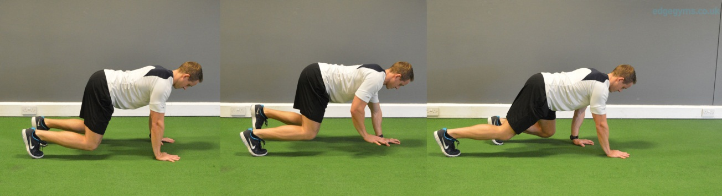
Bear Crawl
Benefits: It strengthens your core and works your entire body, especially your shoulders, arms and glutes. It improves hip mobility and increases your muscular endurance and improves your overall conditioning base.

How to do it: Get down on all fours. Try to keep your hands underneath shoulders. Keep your knees underneath hips. Lift knees off the ground. Allow the posture of your body to be natural. Move forward 10-20 yards, move back 10-20 yards, move sideways 10-20 yards and move in the other direction 10-20 yards.

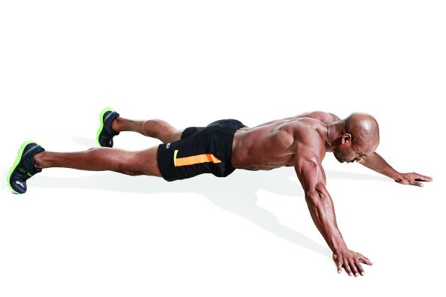
Star Plank
Benefits: This advanced variation of the plank not only creates a greater challenge for your core, but also forces your chest and shoulders to pick up some of the load. You will work your chest, shoulders, and abs at the same time.

How to do it: From a push-up position, walk your palms and toes out and away from your body until they form an x-shape. Brace your core to keep a flat line from your head to your hips and toes. Hold for the required time then walk back to a normal press-up position.

Pistol Squat
Benefits: It simultaneously trains leg strength, balance and mobility with just one exercise. They also help eradicate imbalances between the two sides of the body.
How to do it: Start the pistol standing on one leg, squat down to the position pictured above, then press back up with just that single leg. Keep your base foot flat on the ground – don’t rock up on your toes. The shin is leaning forward with the knee over the toes. Your hamstring and calf of the pressing leg are touching. This will let you know when you are at the bottom of the squat. You’ll find that you can “sit back” slightly once at the bottom. Your torso is leaning forward, close to your pressing leg so that your weight is forward and you maintain balance. When you start your descent to the ground, the arms are held out in front and the free leg is held out straight in front of you. Extending the arms forward helps to keep weight balanced, as well as providing some lateral stability.

Mountain Climbers
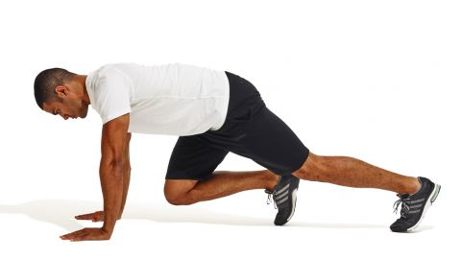
Benefits: This move is about to blast calories with intense cardio while also targeting your abdominal muscles and upper body
How to do it: Start in a traditional plank — shoulders over hands and weight on just your toes. With your core engaged, bring your right knee forward under your chest, with the toes just off the ground. Return to your basic plank. Switch legs, bringing the left knee forward. Keep switching legs and begin to pick up the pace until it feels a little like running in place in a plank position.Continue "running" in your plank for one minute.

Clock Lunge
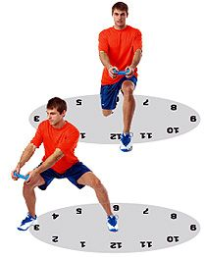
Benefit: Legs are the primary beneficiary, (quads and hamstrings muscles) but you’ll also be pleased by the improved rigidity of your derrière. There are also some core benefits from any kind of lunging as well as improved hip flexibility.
How to do it:
Form is key to a lunge in any direction. Keep your upper body straight as you move, with your chin up and your abs braced.
Start by stepping forwards and lower your hips until both knees are bent at 90°, with your front knee above your foot. Then push back up. That’s your standard lunge and the first part of the clock lunge. The 12 o’clock lunge, if you will.
The next step is a side lunge to your right. Make sure to keep your upper body straight and over your leading leg as you lower, keeping the trailing leg straight. Push back the to starting position. That’s your 3 o’clock lunge done.
Next up is a reverse lunge (towards 6 o’clock – you’re getting this, right?) and lower until both knees are bent at 90°, then push back up.
Finish the round with a 9 o’clock side lunge, leading with your left leg. Now you lunge to 2 o’clock, 7 o’clock, 10 o’clock and 5 o’clock.
Triceps Dip
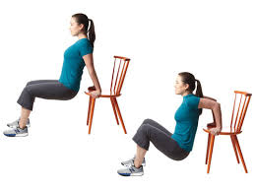
Benefit: Strengthening your triceps — the muscles that run on the backside of your upper arm
How to do it: Position your hands shoulder-width apart on a secured bench or stable chair.
Slide your butt off the front of the bench with your legs extended out in front of you.
Straighten your arms, keeping a little bend in your elbows to keep tension on your triceps and off your elbow joints.
Slowly bend your elbows to lower your body toward the floor until your elbows are at about a 90-degree angle. Be sure to keep your back close to the bench.
Once you reach the bottom of the movement, press down into the bench to straighten your elbows, returning to the starting position. This completes one rep.
Keep your shoulders down as you lower and raise your body. You can bend your legs to modify this exercise.
For some extra fire, reach right arm out while lifting left leg.

Boat Pose
Benefit: An abdominal strengthener and deep hip flexor strengthener
How to do it: Begin in a seated position with your knees bent and your feet flat on the floor. Lift your feet off the floor.
Your torso will naturally fall back, but do not let the spine round. Straighten your legs to a 45-degree angle if you can do so without losing the integrity of your upper body.
You want to keep your torso as upright as possible so that it makes a V shape with the legs. Balance in this position.

Single Leg Squats
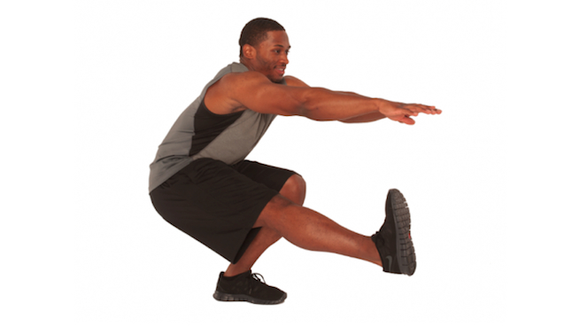
Benefit: Strengthen the hips, legs (hamstrings, quadriceps), glutes, calves, core muscles and increase flexibility
How to do it: Stand on one leg with your foot pointing straight ahead and the knee of the other leg slightly bent.
You can have your arms extended for balance or kept at your sides. Roll your shoulder blades back and keep your back straight. Keep your weight centered over the ball of your foot, your upper body erect, and your head facing forward.
Raise the non-supporting foot from the floor slightly. Lower to a squat position, keeping the knee of the supporting leg centered over the ball of the foot.
Start with shallow squats and work your way closer to the ground. Alternate each leg.

Shoulder stabilization series (I-Y-T-W-O)

Benefit: Shoulders

How to do it: Lie facedown on the floor with arms extended overhead and palms facing each other. Move your arms into each letter formation. Gimme a I, Y, T— you know you want to! You can alternate palms in, palms up, thumbs up, thumbs down, thumbs in.

Squat Punches

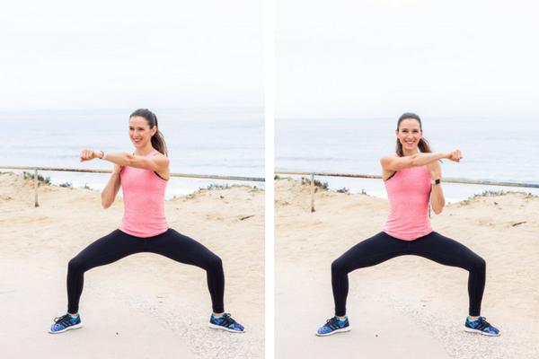

Benefit: This exercise will work your core and obliques, arms, booty, and legs with some cardio
How to do it: Stand with your feet wide, toes pointing out.
Bend your knees, lowering your hips deeply, so your thighs are parallel with the floor.
Make sure to keep your weight back on your heels. Punch to the left, then right. Return to standing and repeat.
Alternating toe touches
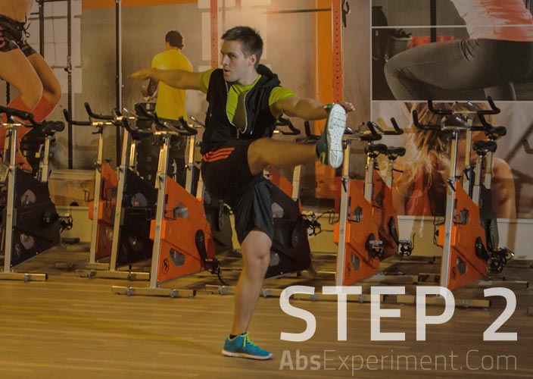
Benefit: Improves postural support, balance, and stability. Supports the development of strong and functional core.
How to do it: Stand tall with your feet shoulder-width apart.
Raise your arms to the side at a level of the shoulders. Engage the abs. This will be the starting and the middle position.
To begin the exercise lift the right leg up as high as possible without leaning backwards. Simultaneously rotate your upper body to your right side while trying to touch the toe with your left hand. Exhale during this part of the movement.
In a controlled motion return back to the starting position. Inhale on the way back.
Now do the same on the other side.
Keep alternating sides until you reach a desired number of repetitions or until your abs fatigue and you no longer can sustain a good form.

Shoulder Touches
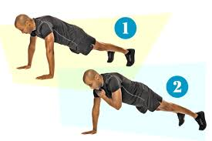
Benefit: Strengthen chest, shoulders, triceps, abs
How to do it: Get into a push-up position on the floor with arms directly beneath your shoulders and hips forming a straight line from your shoulders to your feet.
Remaining as stable as possible, lift one hand off the floor and touch the front of the opposite shoulder. Place hand gently back on the floor.

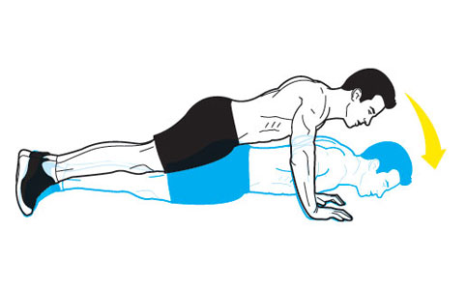
Standard Pushup
The benefit: The standard pushup works your chest, shoulders, triceps, and core.
How to do it: Place your hands slightly beyond shoulder-width apart. Set your feet together and straighten your arms and legs. Your body should form a straight line from ankles to head. Keeping your elbows pulled in toward your sides, lower your chest to an inch above the floor, and press back up.

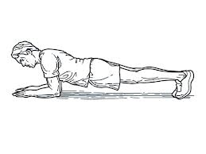
Front Plank

The benefit: Works your abs and back

How to do it: Lie prone on mat. Place forearms on mat, elbows under shoulders. Place legs together with forefeet on floor. Raise body upward by straightening body in straight line. Hold position.

**Option: Alternate raising one foot/leg off the floor and hold for 5-10 sec to increase difficulty

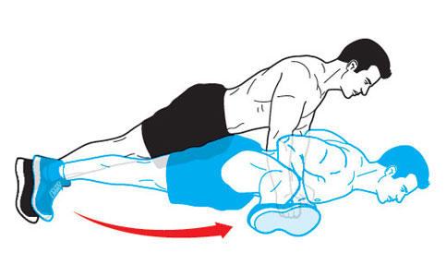

Leg-Kick Pushup
Origin: The Netherlands
The benefit: By forcing you to hold a position, it activates more muscle in your chest and shoulders than a standard pushup does. It also helps develop strength and flexibility in your hip flexors, glutes, and hamstrings.
How to do it: Assume a pushup position, and then lower your body until your chest nearly touches the floor. Kick your right leg out to the side as close to a 90-degree angle as possible without bending your knee. Pause, and move your leg back to the starting position. Push your body back up, and repeat with your left leg.

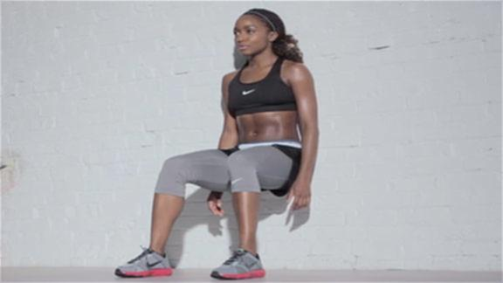

Wall Sit
The benefit: Quadriceps, glutes, hamstrings, calves
How to do it: Start with your back against a wall with your feet shoulder width and about two feet from the wall. Slowly slide your back down the wall until your thighs are parallel to the ground.

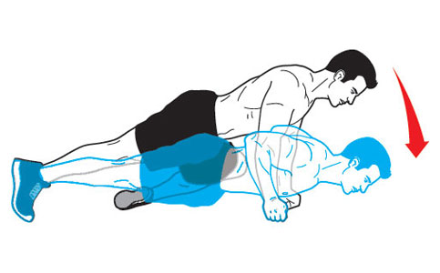
Knee-to-Opposite-Elbow Pushup
Origin: Thailand
The benefit: It uses rotation to work your abdominal muscles, hip flexors, and back in addition to targeting your chest and triceps.
How to do it: Assume a pushup position, but form fists with your hands so your knuckles are flat against the floor. Bring your right knee to your left elbow, and pause before returning your leg to the starting position. Now lower your body as you would for a standard pushup. Push back to the starting position and repeat, this time bringing your left knee to your right elbow.

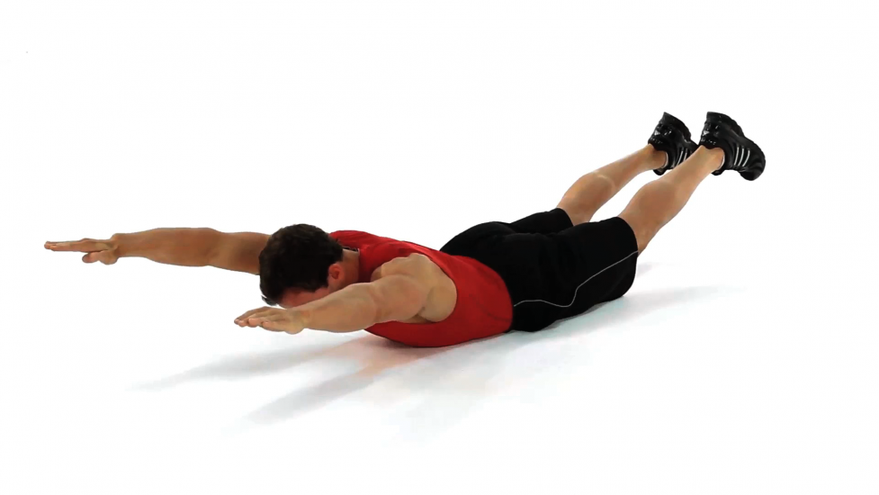
Superman
The benefit: lower back, upper back, shoulders
How to do it: Lie face down with arms out straight in front of you. Raise your arms and gently extend the spine to raise the chest slightly off the floor to a comfortable height, and raise the legs off the ground, forming an elongated 'u' shape with your body. The arms and legs should be several inches off the floor.
**Option: You can alternate moving your arms back and forth in a punching motion or moving arms and legs in and out ( jumping jack motion while face down).

Aquaman
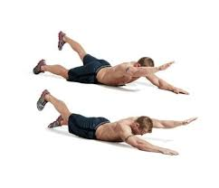

Benefit: lower back, upper back, shouders

How to do it: For this variation of Superman, first lift your right arm and the left leg as much as you can.

And when you bring the two down, lift your left arm and your right leg. Do both these movements as fast as possible.

Glute Bridge with Leg Kick
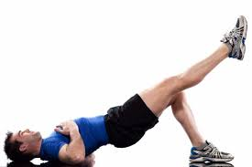

Benefit: Strengthen glutes, hamstrings, hips, abs, and lower back

How to do it: Lie on your back with both knees bent.
Lift your hips into the air as high as you can, simultaneously squeezing your glutes and keeping your upper back on the floor.
Once you are in the bridge position, extend one lower leg straight out and hold for 5-10 seconds.
Lower the leg, then kick and hold with the opposite leg.

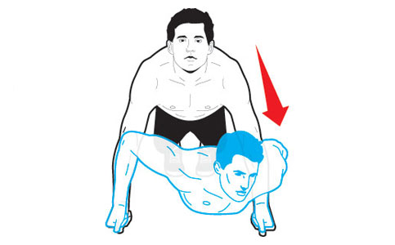

Triangle Pushup
Origin: Brazil
The benefit: It forces one arm to work harder to handle a heavier load, and changes the angle of movement to stimulate more muscle.
How to do it: Assume a pushup position, but form fists with your hands so your knuckles are flat against the floor. Lower your chest to your left hand, pause, and push back up. Repeat, this time lowering your chest to your right hand. Alternate sides each rep.

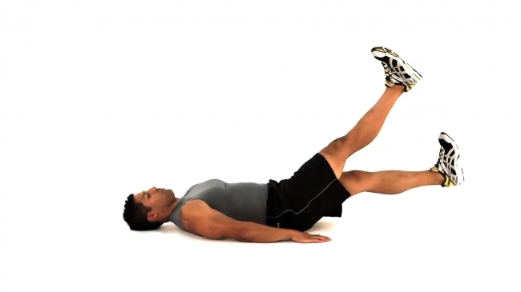

Abdominal Flutter Kicks
The benefit: Works the abs, core muscles and hip flexors

How to do it: Start by lying flat on your back on a mat with your arms by your sides and your palms down. Extend your legs fully with a slight bend in your knees. Lift your heels about 6 inches off the floor. Make small, rapid up and down scissor-like motions with your legs. The key is to focus on having your midsection do the work and to keep your abs constantly contracted throughout the exercise.

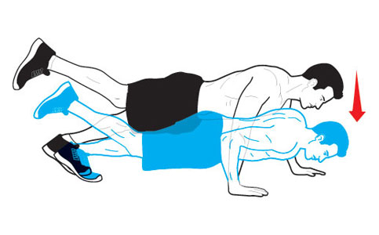

Alternating Grip Single-Leg Pushup
Origin: England
The benefit: It works your lower-abdominal muscles and places more demand on your chest and serratus anterior, an important posture muscle that runs from your chest and along your rib cage to your shoulder blade.
How to do it: Place your right hand in a standard pushup position, but move your left hand a few inches forward. Raise your right leg and then lower your body until your chest nearly touches the floor. Push back to the starting position. Do half your reps, then switch arms and legs and finish your set.

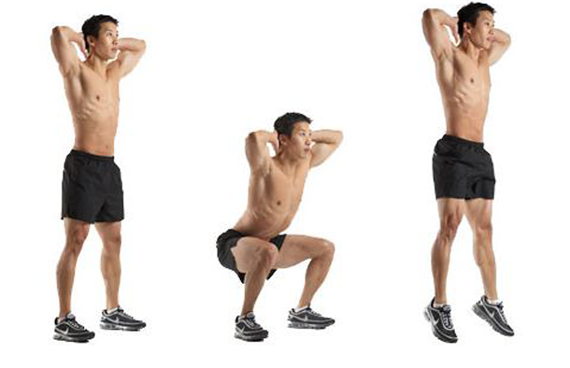
Squat Jumps (with pause in the squat position)
The benefit: Works your quadriceps and calves

How to do it: Place your hands behind your head and keep your back straight. You go down into a 1/2 squat position with your thighs roughly parallel to the floor. From here, you use a 3-5 second pause and then explode up forcefully once again driving through the balls of the feet.

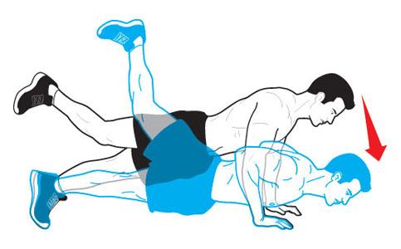

Uchi Mata Pushup
Origin: Japan
The benefit: It increases activation of your core, lower back, and hamstrings while also boosting demand on the muscles in your shoulders.
How to do it: From a pushup position, lift your right foot so your leg is parallel to the floor. Lower your body until your chest nearly touches the floor. Now raise your lifted leg higher into the air. Push back to the starting position. Do half your reps, switch legs, and finish your set.

Side Plank
The benefit: The side plank challenges your stability and improves core strength by working the obliques and deltoids.

How to do it: Lie on your left side, raising yourself onto your left forearm. Place your left shoulder directly above your left elbow, keeping your shoulders, hips and knees in alignment. Rest your right arm along the side of your body. Tighten your abdominal muscles.

Rear Lunge with Twist
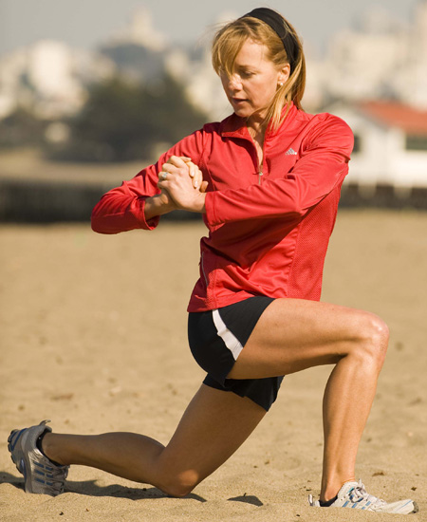
The benefit: The lunge is an excellent full-leg workout. The primary muscles engaged include the quadriceps, the muscles and the front of the thigh, and the hamstring, which runs up the back of the leg. It also benefits the hip flexors, calves, lower back and obliques. The back lunge enables you to protect your knees if knee problems are a concern.
How to Do It: Stand with feet shoulder-width apart, with hands and arms hanging by your side. Look straight ahead, straighten your back and pull abdominal muscles in tight.
Take a large step backward landing on the ball of your foot. The step should be long enough to where the back foot's hell lifts off the ground and the back knee almost touches the ground. Your front knee should line up over the top of foot (not the toes) and remain at 90 degrees.
Once you are in the desired position, carefully twist your torso and then return to your starting position. Repeat for the opposite leg.
Skaters
Benefit: Strengthen the glutes, hamstrings, thighs, and core, all at once
How to do it: Start in a small squat. Jump sideways to the left, landing on your left leg. Bring your right leg behind to your left ankle, and don't let it touch the floor.
Reverse direction by jumping to the right with your right leg. This completes one rep.

Quadruped Limb Raises
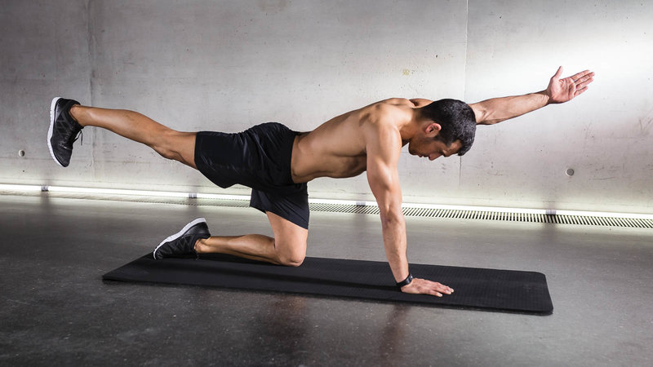
Benefits: Strengthen back, shoulders, hips
How to do it: Get on all fours. Place your hands shoulder-width apart directly under your shoulders. Keep your elbows slightly bent.Bend your elbows slightly and place your knees directly under your hips. Your body should be parallel to the floor. Make sure that your body forms a straight line from your head to your buttocks. Extend your right arm forward and your left leg backward while keeping your back straight. Hold this position for three to ten seconds and then lower back to start. Repeat on the other side.

Single-Leg Plank
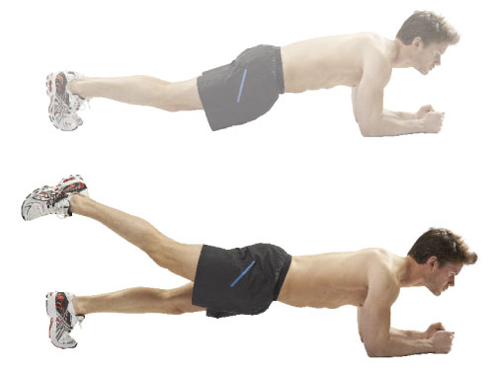

The benefit: Increase stability and improves strength in abs, lower back, deltoids and glutes.
How to do it: Come into upper push-up position with your hands beneath your shoulders, feet together. Curl your toes so that some of your weight is on the back of them. Keeping abs tight and tailbone straight, lift one leg a few inches off the floor and point your toes; hold for five seconds and release. Repeat with the opposite leg to complete the set. Do 5 to 8 sets.

Single -Leg Glute Bridge

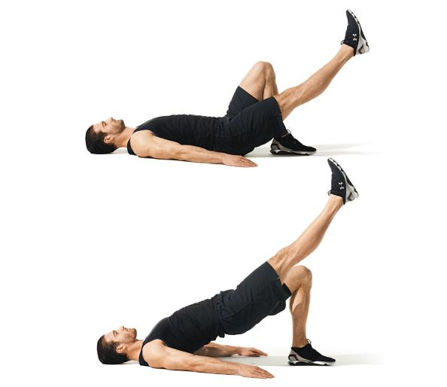

The benefit: Strengthen legs, hips and glutes

How to do it: Lie on your back, and place your hands on the floor for stability as you bend one leg and lift the other leg off the ground.

Pressing your heel into the floor, lift your pelvis up, keeping your body in a stiff bridge position. Slowly lower your body to the floor and repeat on each side.

Elevated Bird Dog

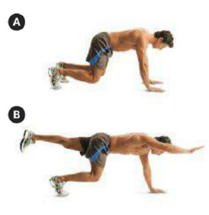

The benefit: Increases core strength in both abs and lower back and improves stability
How to do it: Start with on your hands under your shoulders and knees under your hips and off the floor.
While keeping your head, neck, and back straight, raise your right arm and reach it forward until it’s in line with your torso.
As you bring your arm forward, kick your left leg backwards until it’s straight and in line with your torso, hold for 1 second.
Slowly bring your arm and leg back to the ground and repeat with the opposite arm and leg

Bear Crunch
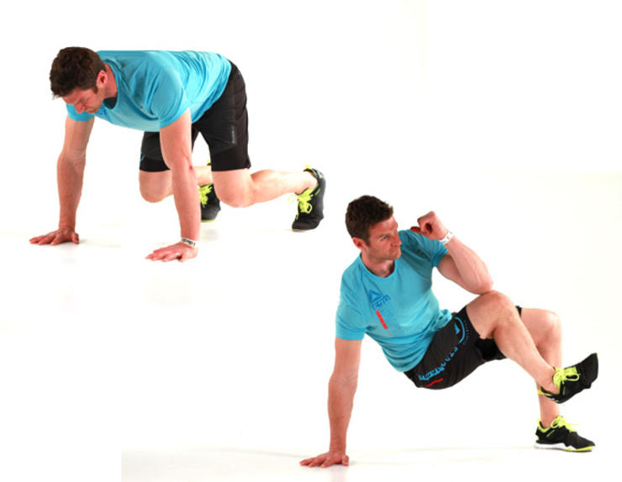
The benefit: Strengthen core, deltoids, stabilitiy
How to do it: http://www.menshealth.com/video/bear-crunch

SPIDERMAN PLANK CRUNCH

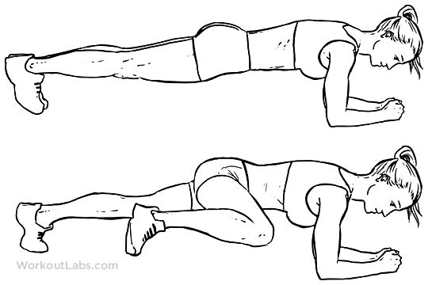
The benefit: Build ab strength, better stability, lower back strength
How to do it: Assume a regular plank position and pull one knee to the outside shoulder or elbow region. Repeat with the other knee.

